Preliminary Design
Data Flow

Requested by: Dr. Darren Lim
Assistant Professor
Department of Computer Science
Siena College

Dr. Manimoy Paul
Assistant Professor
Department of Quantitative Business Analysis
Siena College

International Online Survey
(IOS)

Bad Robot Enterprises

Prepared by: Paul Borchers
Ryan May
Ryan Rose
Vito Urbano

November 28, 2007

International Online Survey

Preliminary Design

Table of Contents

Section 6: Data Flow Diagrams
6.0 Data Flow Diagram Legend------------------------------------------------------------ 2
6.1: Context Diagram------------------------------------------------------------------------ 3
6.2: Level 0----------------------------------------------------------------------------------- 4
6.3: Administrator Level 1------------------------------------------------------------------ 5
6.4: Administrator Level 2------------------------------------------------------------------ 6
6.5: Administrator Level 3------------------------------------------------------------------ 7
6.6: Student Level 1------------------------------------------------------------------------- 8
6.7: Teacher Level 1------------------------------------------------------------------------- 9
6.8: Teacher Level 2------------------------------------------------------------------------- 10
6.9: Teacher Level 3------------------------------------------------------------------------- 11

6.0: Legend

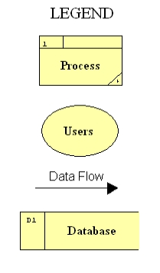

6.1: Context Diagram
Data Flow Diagram - The Data Flow Diagram (DFD) is used for process modeling. The DFD clearly represents the transactions between processes and users; and the transformation of data in our program.

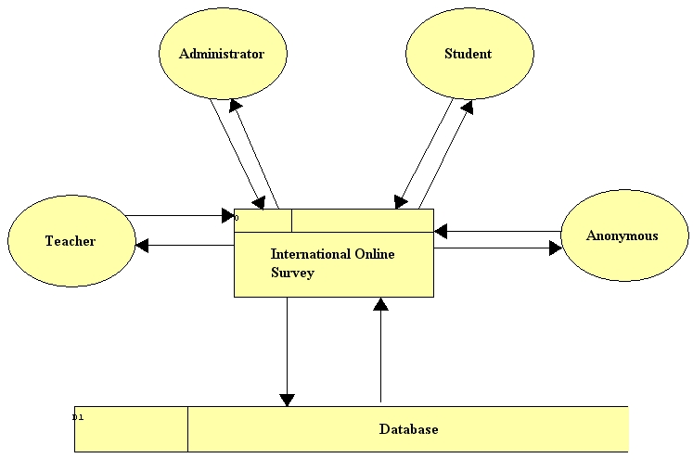

6.2: Level 0

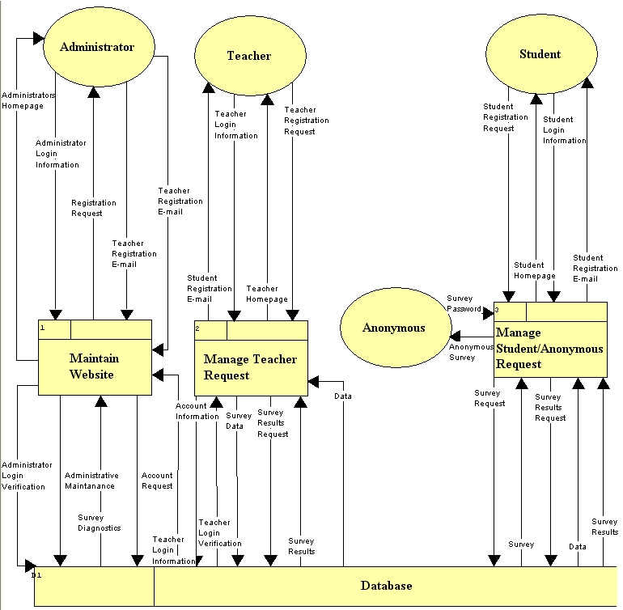

6.3: Administrator Level 1

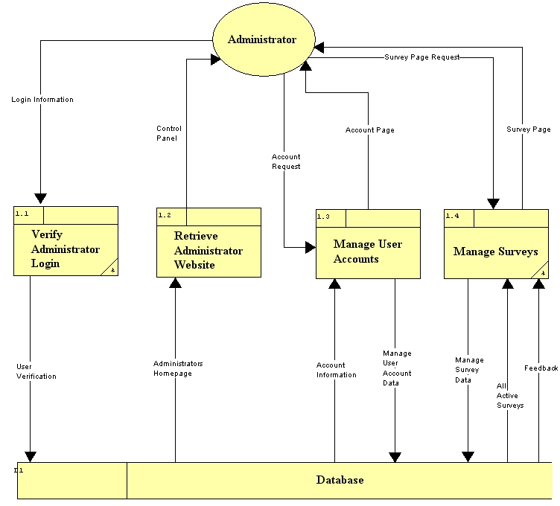

6.4: Administrator Level 2

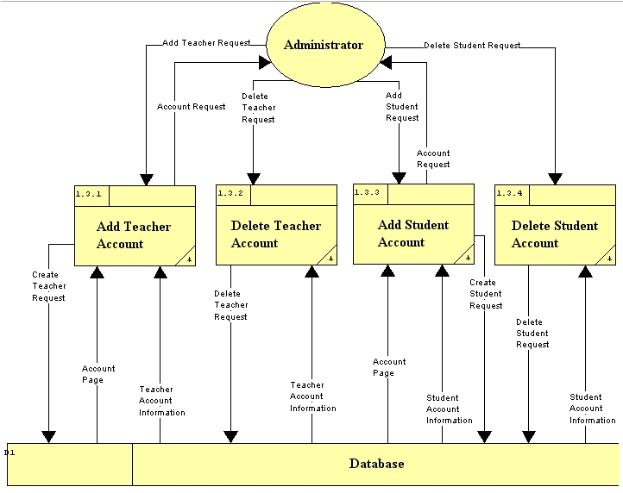

6.5: Administrator Level 3

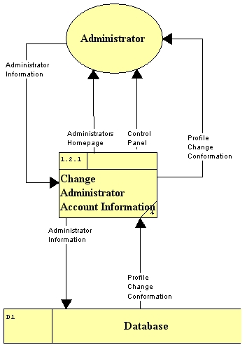

6.6: Student Level 1

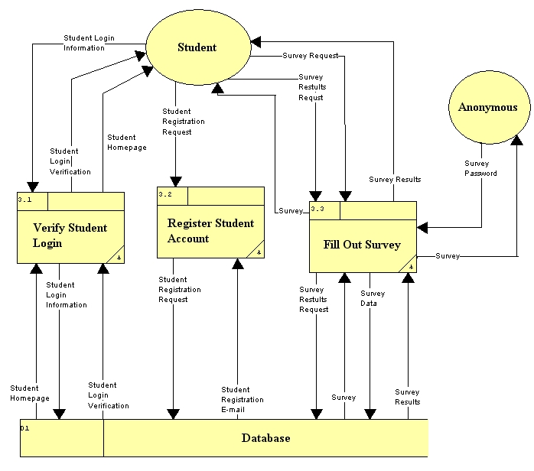

6.7: Teacher Level 1

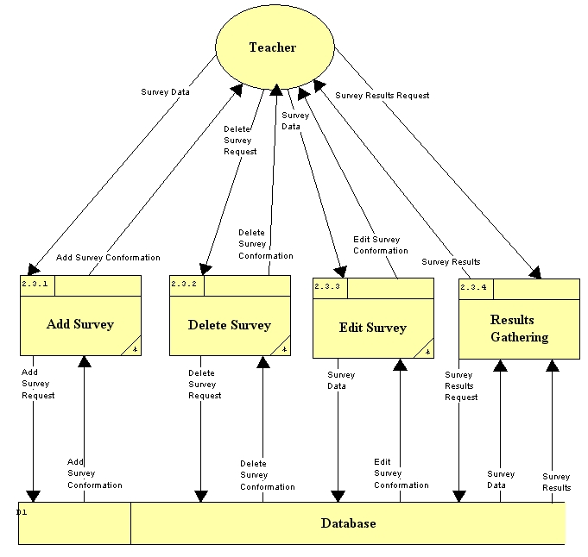

6.8: Teacher Level 2

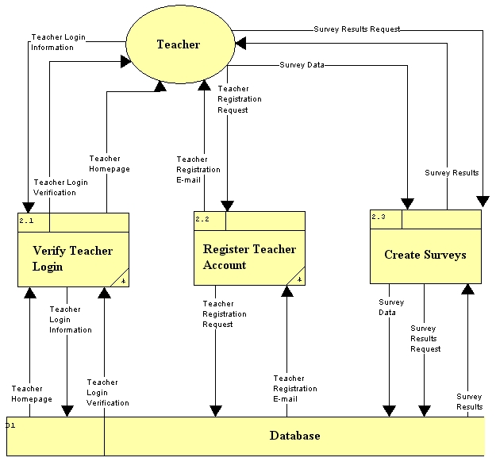

6.9: Teacher Level 3



